**Lead Scoring Subjective Questions  
  
1. Which are the top three variables in your model which contribute most towards the probability of a lead getting converted?**  
Top Positive Features Driving Conversion

1. Lead Origin_Lead Add Form (3.645):

Leads originating from the "Lead Add Form" are highly likely to convert.

Business Insight: Focus on optimising the form's visibility and design to capture more leads.

1. Tags_Will revert after reading the email (3.146):

Leads marked with this tag are more likely to convert.

Actionable Step: Prioritise follow-ups for these leads to ensure timely engagement.

1. Tags_Other (2.880):

Other tags also show a positive correlation.

Since Tags other doesn’t classify the group at a granular/ doesn’t give a specificity

level, taking the next feature

also .

1. Last Notable Activity_SMS Sent (1.808):

SMS interactions drive conversions.

Actionable Step: Invest in SMS campaigns for leads showing interest.

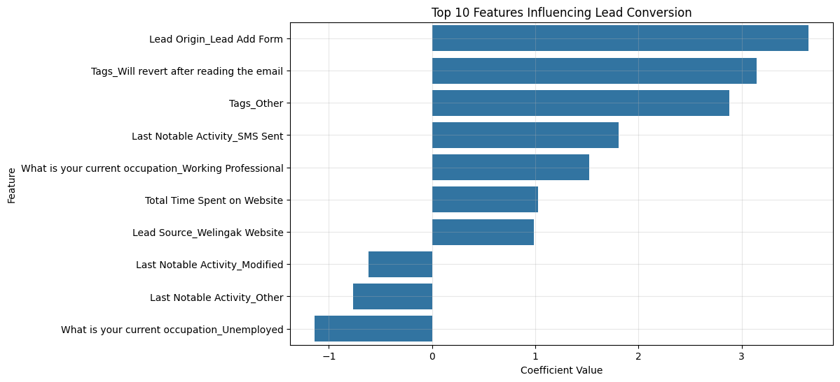

**2. What are the top 3 categorical/dummy variables in the model which should be focused the most on in order to increase the probability of lead conversion?**  
  
1. Lead Origin_Lead Add Form (3.645)

Ensure the form is prominently displayed on the website.

Simplify the form to improve the user experience.

Use A/B testing to optimize form design for better conversion rates.

2. Tags_Will revert after reading the email (3.146)

Prioritize follow-ups with these leads via targeted email or phone communication.

Use CRM tools to monitor and ensure timely engagement with these leads.

3. Tags_Other (2.880)

Analyze what qualifies leads under this category and refine tagging for better segmentation.

Identify common patterns or traits among these leads to create specific engagement strategies.

**3. X Education has a period of 2 months every year during which they hire some interns. The sales team, in particular, has around 10 interns allotted to them. So during this phase, they wish to make the lead conversion more aggressive. So they want almost all of the potential leads (i.e. the customers who have been predicted as 1 by the model) to be converted and hence, want to make phone calls to as much of such people as possible. Suggest a good strategy they should employ at this stage.**

To maximize lead conversions during the intern phase, X Education should adjust its approach to make the process more aggressive and efficient. The focus should be on identifying as many potential leads (Converted = 1) as possible, even if it means casting a wider net by slightly compromising on precision.   
  
Lower the Decision Threshold

The current decision threshold (e.g., 0.41) can be adjusted to a lower value, such as 0.2, to increase recall. By doing so, the model will classify more leads as potential converters, ensuring that fewer genuine opportunities are missed. While this approach might slightly reduce precision, the sales team will be able to reach a larger pool of potentially convertible leads.  
  
Prioritize High-Scoring Leads

Within the expanded pool of leads classified as 1, priority should be given to those with higher lead scores (predicted probabilities). Leads with higher scores are more likely to convert, so interns should focus on reaching these leads first.

Effective Utilization of Interns

The identified potential leads should be evenly distributed among the 10 interns based on criteria such as lead score, region, or lead source. This ensures efficient and personalized communication with all potential customers

Multi-Channel Communication

To increase engagement, a combination of phone calls and SMS should be employed. Leads showing high engagement (e.g., longer website visit durations) should be contacted via calls, while SMS campaigns can be used for others. Personalized messaging should be emphasized to increase the chances of conversion.

**4. Similarly, at times, the company reaches its target for a quarter before the deadline. During this time, the company wants the sales team to focus on some new work as well. So during this time, the company’s aim is to not make phone calls unless it’s extremely necessary, i.e. they want to minimize the rate of useless phone calls. Suggest a strategy they should employ at this stage.**

Increase the Decision Threshold

To minimize unnecessary calls, the decision threshold for classifying a lead as 1 (converted) should be raised. A higher threshold will identify only the most confident predictions, ensuring that the sales team contacts leads with a very high probability of conversion, i.e we can increase it to .5 or.6  
  
Emphasize Alternative Engagement Channels

For leads that fall below the higher threshold, the sales team should rely on alternative engagement methods, such as automated emails or SMS campaigns. This reduces the need for direct phone calls while maintaining some level of engagement with potential customers.  
Responses from these channel can be used to gauge the conversion metric,i.e sentiment analysis can be done to check whether a customer is willing to convert/satisfied with responses they get.